hOME iSOLATION

A Visual Storyboard + Mood-board

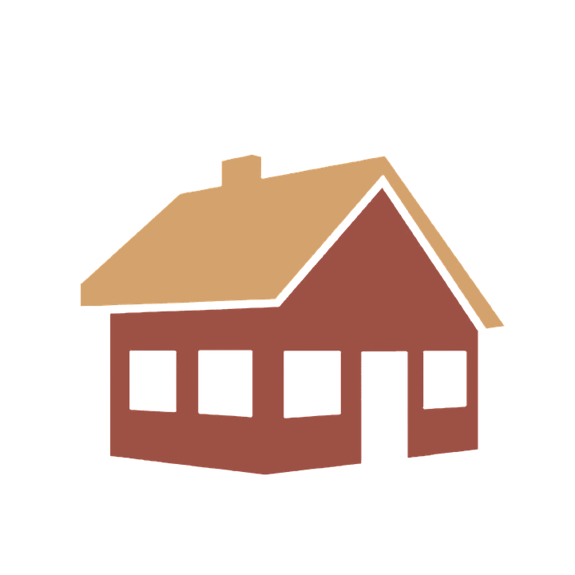

November 12, 2020

aNDREW lETAILLEUR

**“Must Have” Storyboard, at minimum**

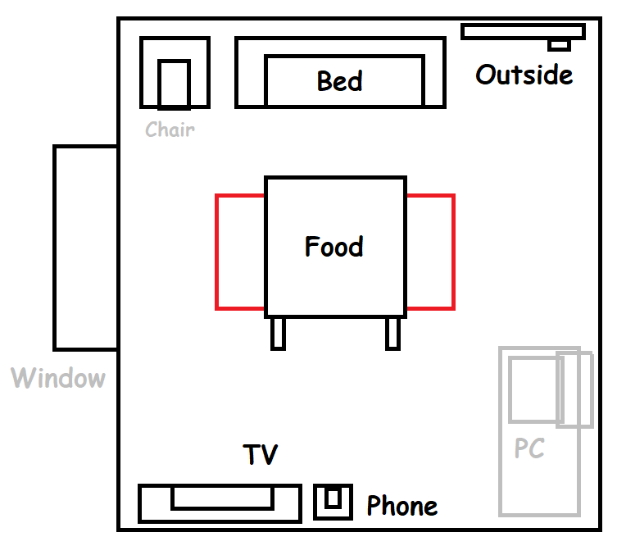

Layout of a “simplified” room, with the minimum amount of interactions required to set the message between mental health and self-isolation. Should still allow some interactions to maintain mental health.

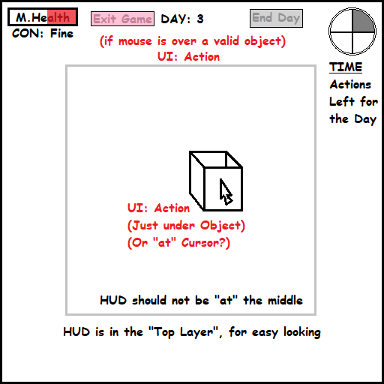

GUI Display, showing the current mental health and condition. Penalty effects can happen if mental health or condition is low. While if in ill condition, you may die each day, and should be unable to go out for 14 days.

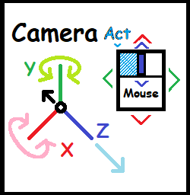

Left mouse button for interaction, while zoom in/out is done through the mouse wheel. Mouse movement rotates the camera view, on a “XY rotation” axis.  
Zoom must be capped to bar ‘clipping’ through the room, while interactions should be highlighted by a HUD display nearby the in-game cursor.

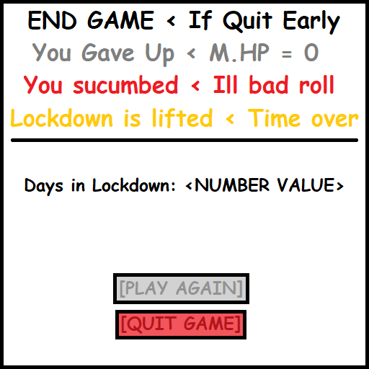

Exit game conditions (by choice, or if health goes ‘bad’, then game over. And chance to ‘restart’ game loop.) Also note how long the lockdown was “lived” for?



Next Day transition, if mental health is low; the camera should briefly “flash” dark at the edges. If mental health is too low (approx. <33%), may wake up with less turns, or even to a surprise “Game Over” condition.

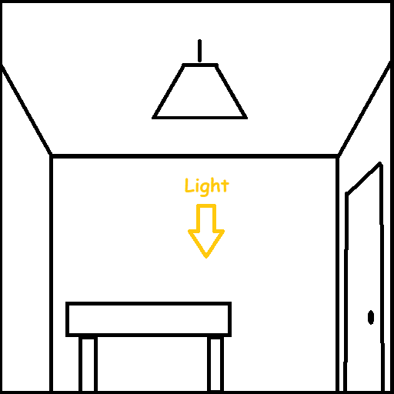

Ceiling view (of rooms), should ideally also contain some form of lampshades. Though in priorities, lighting shouldn’t come ‘as’ important in contrast to creating/sourcing the low poly assets, first.

**“Ideal” Storyboard, at maximum**

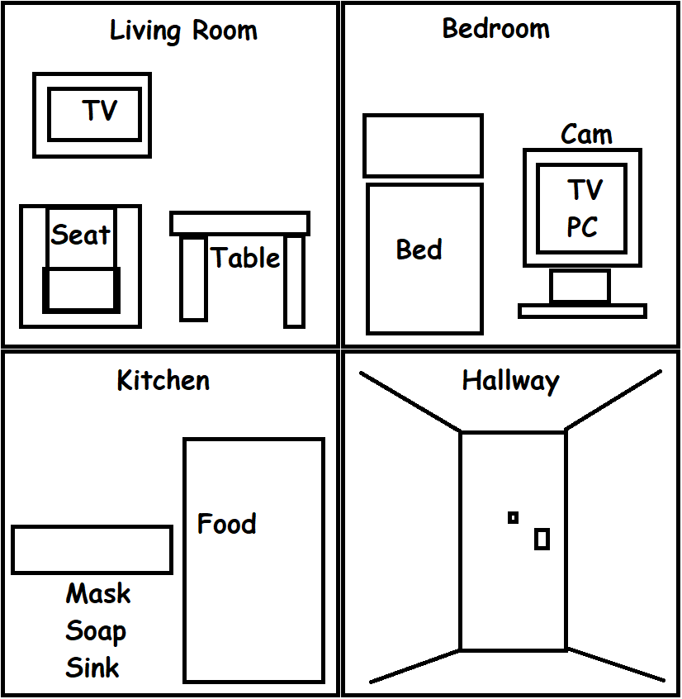

Advanced layout (sketch), if spread to more than “one” room, transition wise. Rooms should lead to/from “Hallway” that is used to go outside. Cleaning and washing mitigates outside doors risk on entering and exiting.

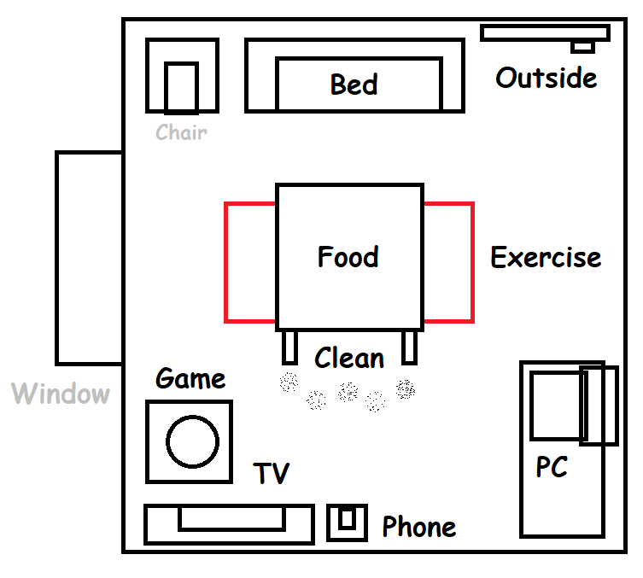

“Diorama” of a condensed room, featuring abstractly; the ‘ideal’ maximum amount of interactions, within one room. Going outside offers the best recovery of mental health, but risks catching “the virus” for each outing.

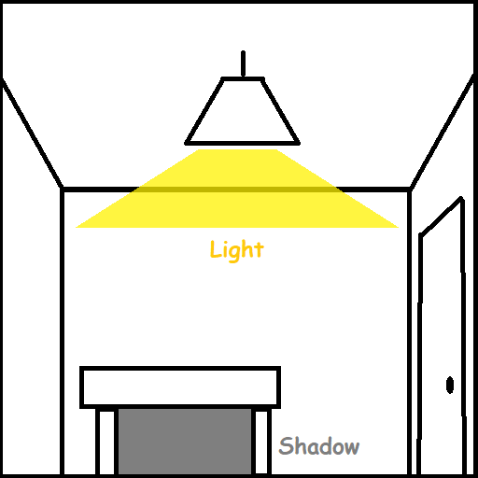

Ceilings should contain a “light source”, for more detailed lighting in a generic lens. If given more detail, this can be more a “hanging lampshade” than a “block LED light”. Light could be triggered by a “switch”.

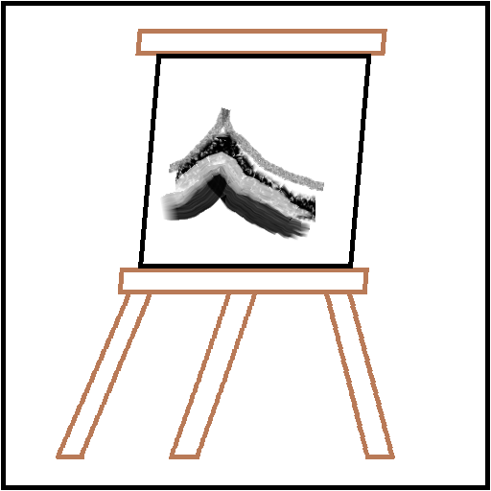

Above all else. Quality of assets should evolve from a “Prototype” Models, to more detailed, Low Poly Models. As the core gameplay mechanics must function properly, first of all.

Hypothetical “screen”, if infected by virus hints at a ‘passed by’ a near dead state, by an ominous ‘fade in/out’ for each day. Each ‘transition’ should hint at how near the player was to dying in game to Corona.

**TITLE**

**\*IMG\***

**[Play Game]  
[Instructions]  
[Credits]  
[Quit Game]**

Nice to have “Main Menu”, that reflects the theme, and crediting any outsourced assets. If unable to include as a screen, the instructions should ideally appear briefly, within the main game itself, before vanishing.

Canvas: On a “Process” from Proto to Low Poly Quality.

**Mood Board (Art Style Direction)**

Key Style & Theme: “Low Poly Realism”, Western Buildings (Indoors, Interiors)

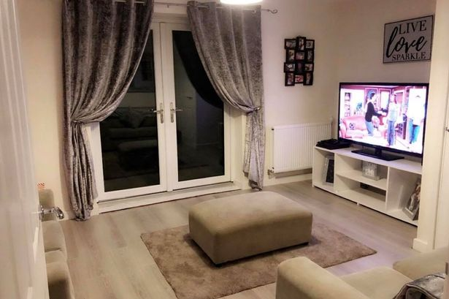Example of a “standard?” living room,   
within a UK “Council House”.

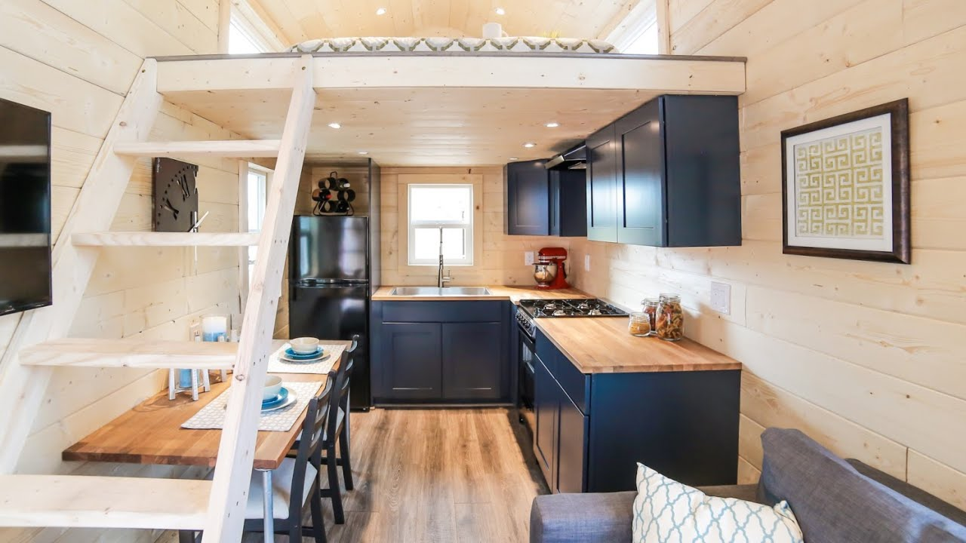“Tiny House”, design idea/concept for a “condensed room” for interactions.

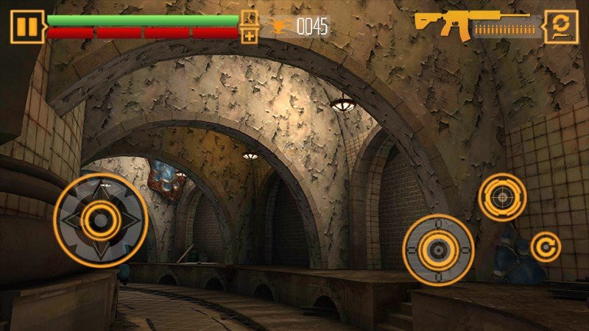Example “UI” to some lens, though it should only display “at the top-end of view.

Article Ref: [HUD Design](https://www.pluralsight.com/blog/film-games/designing-a-hud-that-works-for-your-game)

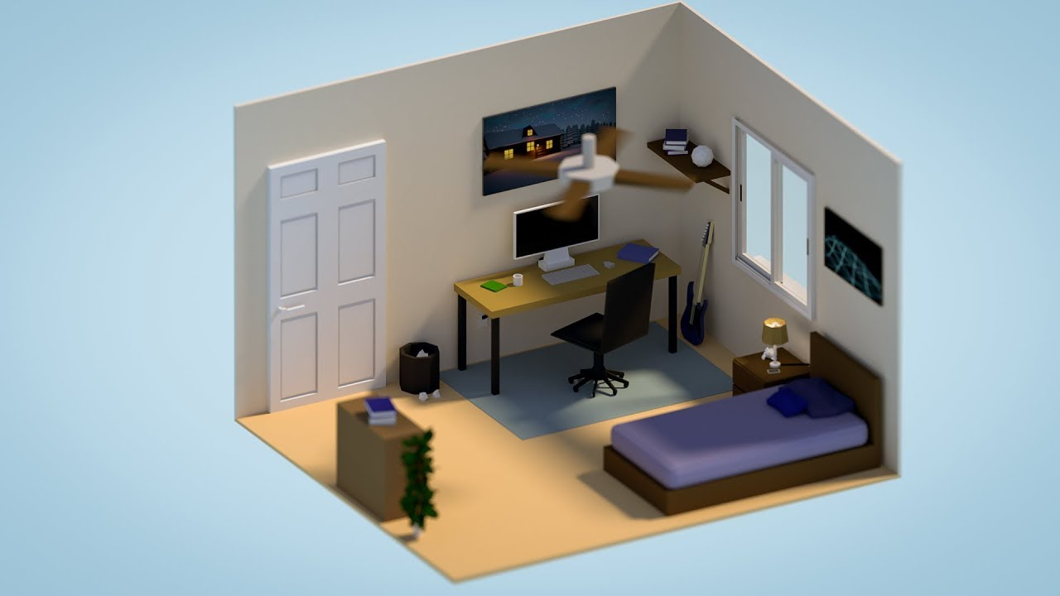Example of a Low Poly interior,   
Bedroom wise under a Diorama.

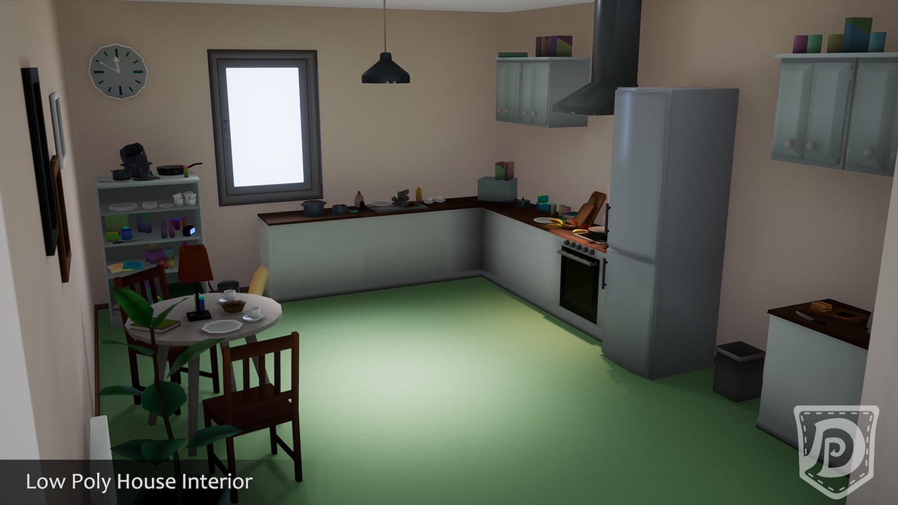Example of a Low Poly house interior,  
with 3D models that could be purchased.

[Low Poly House Interior](https://www.unrealengine.com/marketplace/en-US/product/low-poly-house-interior)

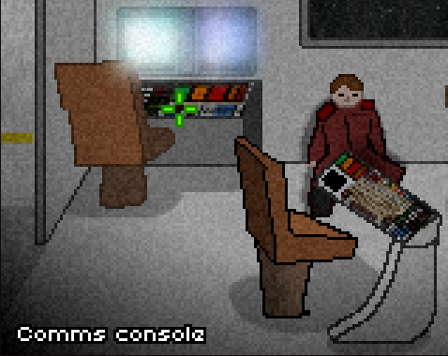  
Don’t Escape 2; “Low Poly” HUD example, displaying object descriptions over intractable objects on mouse hovering.

**Sources for free (to use), 3D Models/Assets, Low Poly:** <https://assetstore.unity.com/> ,